# Laker Legacies – Database Design

## DB Description

The Laker legacies directory, or database, will contain all of the information about various buildings and/or monuments of Grand Valley and their related donors/major contributors.

A donor’s/contributor’s name and short biography should be recorded in the database. Although it is unlikely, it is possible for two individuals to have the same name. Therefore, in order to uniquely identify each contributor, each contributor should have his/her own unique ID number.

Each building/monument has a unique name. The database should record its address, campus, date established, and its GPS coordinates (latitude and longitude).

All donors in the database have donated/contributed toward at least one monument/building. Likewise, all buildings in the database have at least one donor. A donor can donate/contribute toward multiple buildings. Likewise, multiple buildings could have multiple donors.

For visual effect, the database will hold references to image files of both contributors and monuments. Not all monuments/contributors will have a picture; all pictures referenced in the database, however, will refer to a contributor or a monument. A single image cannot refer to multiple monuments. However, a monument can have multiple images of it.

## ER Diagram

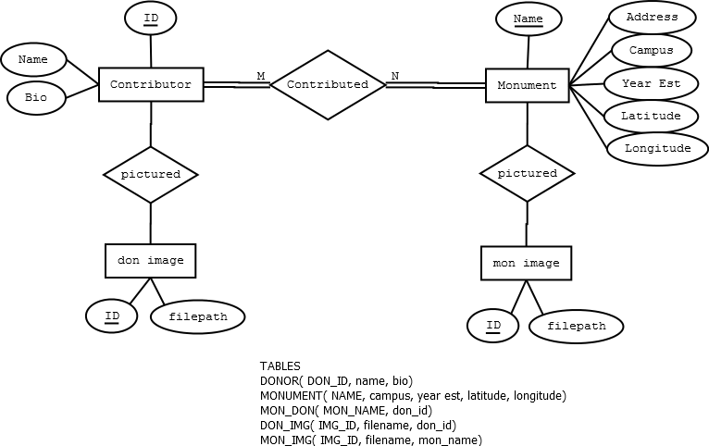

## Relational Tables

|  |  |
| --- | --- |
| *Table Name* | *Attributes* |
| **MONUMENT** | ( Name , Address , Campus , Date_Est , GPS ) |
| **DONOR** | ( ID , Name , Bio ) |
| **DON_IMG** | ( ID, Filepath, Donor_ID ) |
| **MON_IMG** | ( ID, Filepath, Building_Name ) |
| **MONUMENT_DONORS** | ( Building_Name , Donor_ID ) |